MONTCALM CARE NETWORK PROCEDURE 611 North State Street, Stanton, MI 48888
SUBJECT: Duty To Warn | Section: 8331A
Effective Date: November 26, 1996 | Revised Date: September 21, 2021

Public Act 123 of 1989 requires all mental health practitioners to report any information communicated to the mental health practitioner by anyone under their treatment which contains a threat of physical violence against a reasonably identifiable third person, if there is apparent intent, and the ability to carry out that threat in the foreseeable future. Below is a flowchart to assist with the Duty to Warn decision-making process and follow actions.
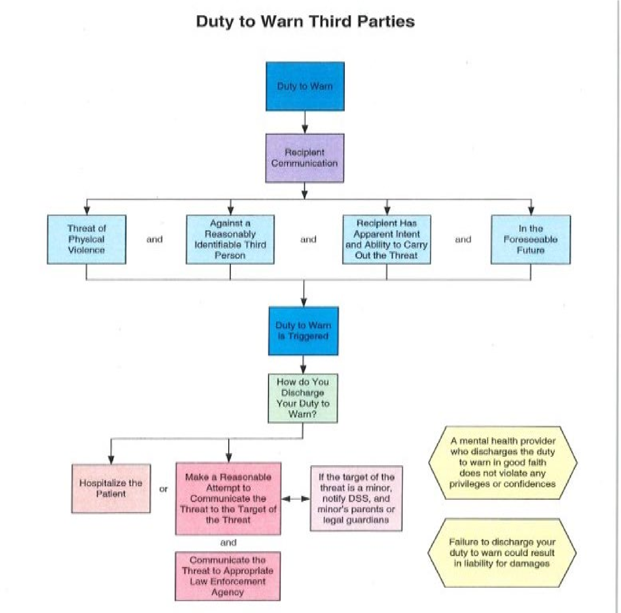
In such situations meeting the above criteria, the staff of the Montcalm Care Network will do the following immediately:
- Facilitate hospitalization or other services for the individual as clinically appropriate. If hospitalization or other services are immediately possible and the consumer’s ability to carry out the threat is negated, then no duty to warn needs to be made.
- If the person making the threat does have the ability to carry out the threat, inform them of the requirements of the Public Act 123.
- Make a reasonable attempt to notify the identified person against whom the threat was made.
- If the identified person is believed to be a minor or incompetent by other than age, the Department of Health and Human Services/Adult Protective Services in the county of residence of the identified person, or parents, legal guardian, or third person where they reside, must be notified.
- Notify the county sheriff, state or local police where the identified person resides.
All documentation of contact and intervention will be contained in a progress note or nonbillable note in the health record of the consumer making the threats.

