End of Services Customer Surveys 2023
Montcalm Care Network distributes satisfaction surveys to all consumer after they have been discharged from services for persons who received Adult & Child Case Management, Adult and Child Outpatient Therapy, and Homebased services. Reason for discharge is not a factor—everyone completing or discontinuing those services receives a survey.
Responses were given on a range from 1 (Strongly Disagree) to 5 (Strongly Agree). The average scores are show below for each question, with year-to-year comparison by program.
Darker green indicates higher levels of satisfaction (average scores closer to a 5 or 4), with gradations to darker orange or red indicating lower levels of satisfaction (as scores average closer to 2 or 1.)
Response rates have significantly declined in the past 2 years; reasons for this decline are uncertain. Distribution continued to be via mail. During the pandemic, somewhat fewer persons were served and significantly fewer persons were discharged, which could account for some of the reduction in numbers. There is also speculation that there may be factors due to the global pandemic (2020, 2021) resulting in persons changes in desire to participate in surveys, or that persons have been “over surveyed” and are experiencing “survey fatigue.” Distribution of surveys has always been by mail.

Attachment A: Adult Average Scores
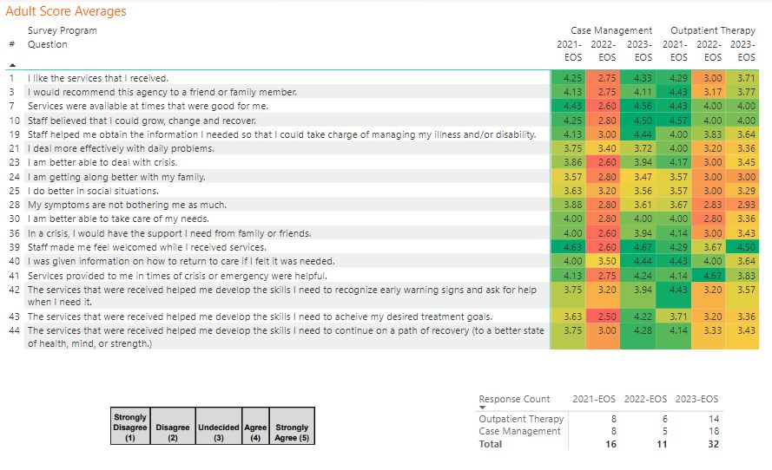
Attachment B: Children Average Scores
