ANNUAL SATISFACTION SURVEY DATA 2023
Consumers were surveyed in the programs of Adult & Child Case Management, Adult & Child Outpatient Therapy, and Homebased Services. Responses were given on a range from 1 (Disagree) to 5 (Agree). The average scores are show below for each question, with year-to-year comparison by program.
Darker green indicates higher levels of satisfaction (average scores closer to a 5 or 4), with gradations to darker orange or red indicating lower levels of satisfaction (as scores average closer to 2 or 1.)
During the pandemic, response rates had significantly declined, primarily due to a change in distribution methods due to the global pandemic; for 2019 and prior years, the survey was distributed face to face, while 2020 surveys were distributed by email, and 2021’s were distributed via a mix of email and telephone surveys. Distribution that is face to face has shown to yield a higher return rate, which provides more reliable scores…scores more representative of the general population of that program. For 2022-23, we have returned to face to face surveys, and response rates have surpassed those prior to the pandemic.
Attachment A: Adult Average Scores
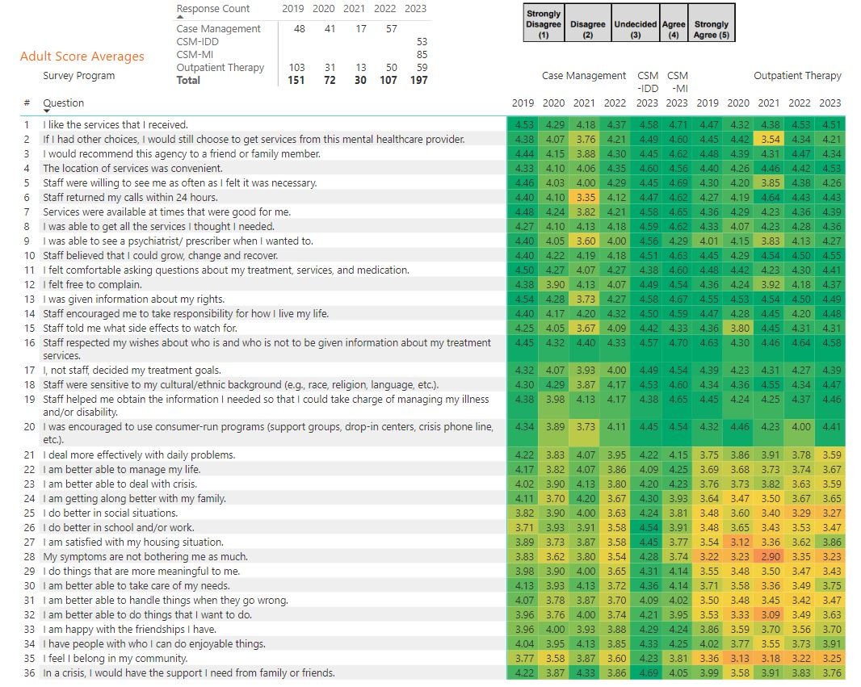
Attachment B: Children Average Scores
